MINI PROJECT 3 – OSINT RECONNAISSANCE
Submitted By : Attia Rawaid
Course: Cyber Security
Target Domain: wus.edu.pk(women University Swabi)
Objective:
The objective of this project is to collect publicly available information about the target website using OSINT (Open Source Intelligence) techniques. Only publicly available information was collected, and no unauthorized access or attack was performed.
Tool 1 – Google Dork:
To find all pages indexed by Google
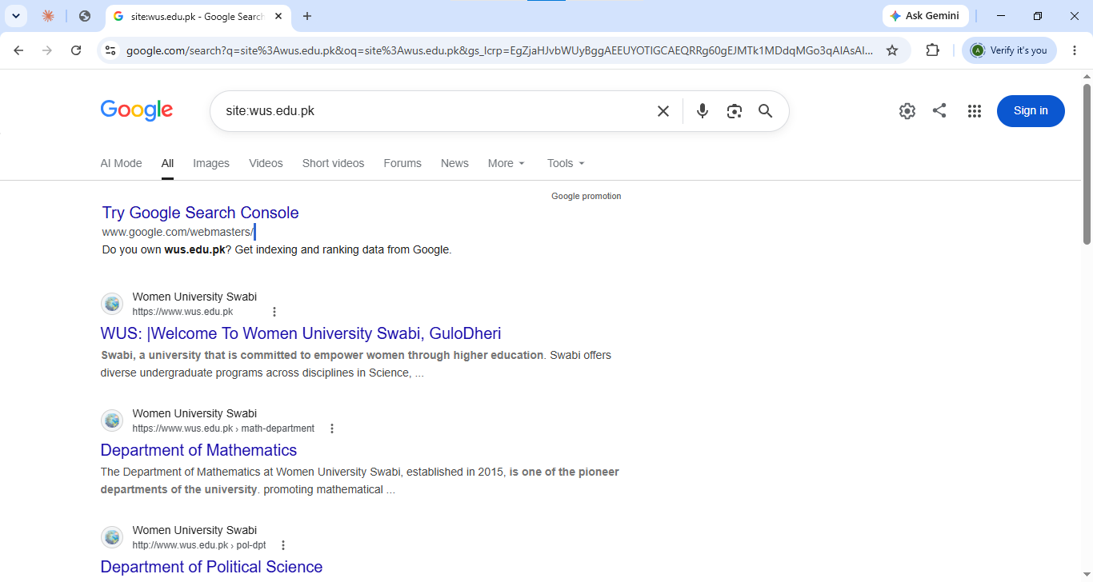
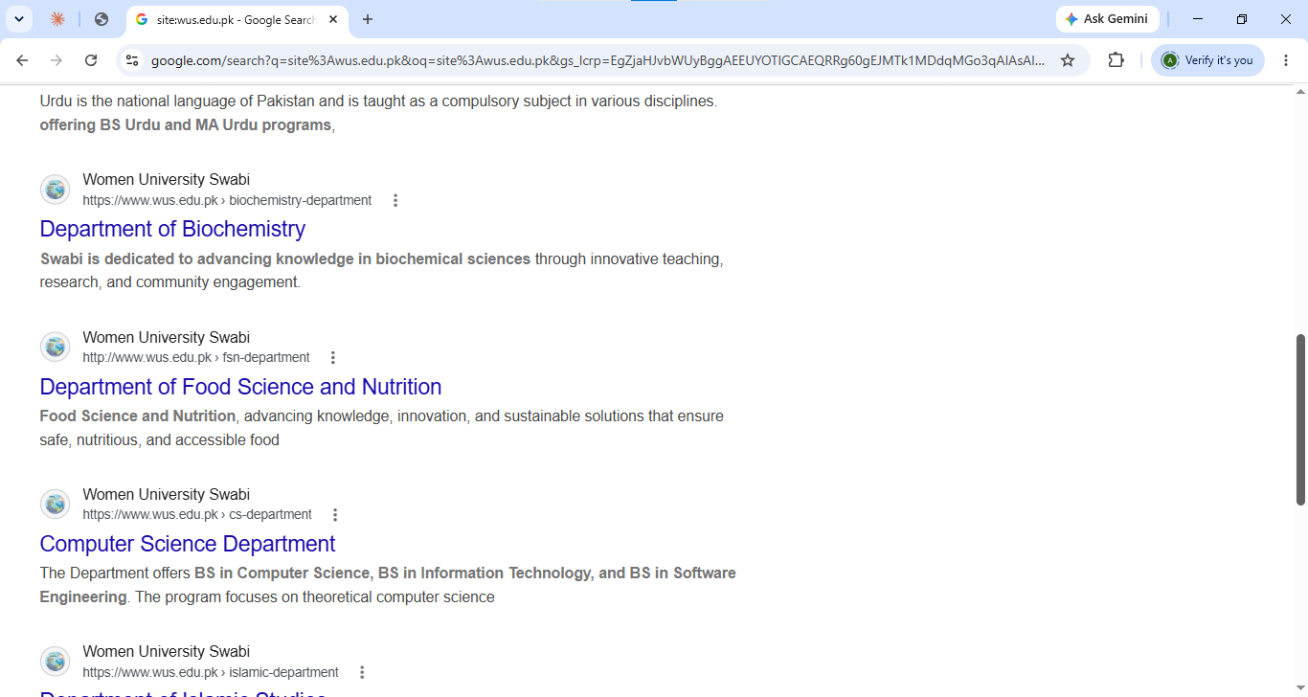
Google displayed the indexed pages of the Women University Swabi website.
Query 2:
To find publicly available PDF documents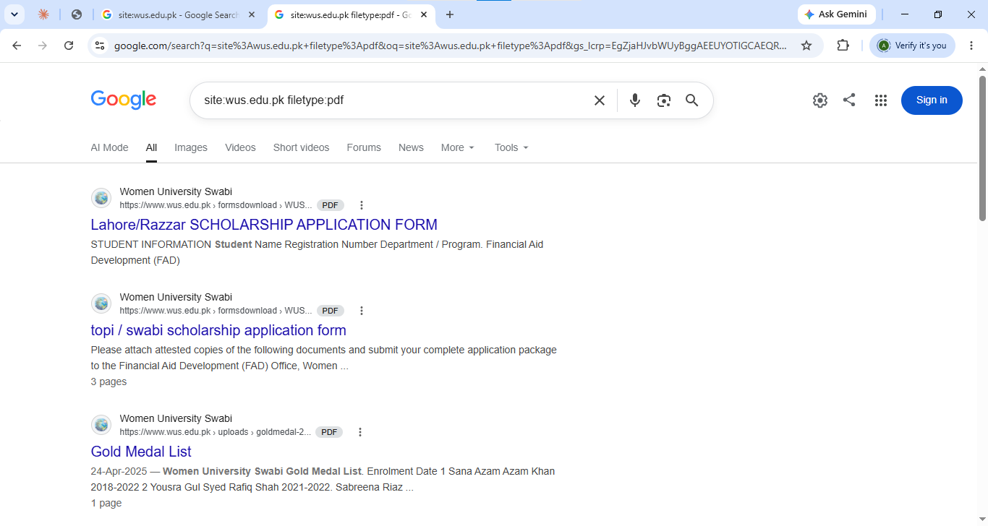

Query 3:
To search for publicly indexed login or admin pages.

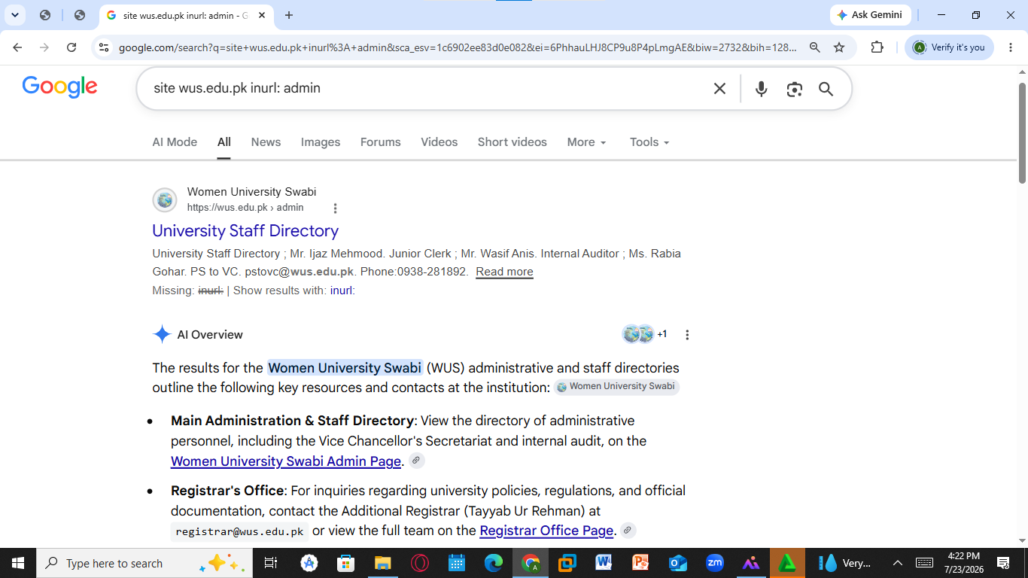
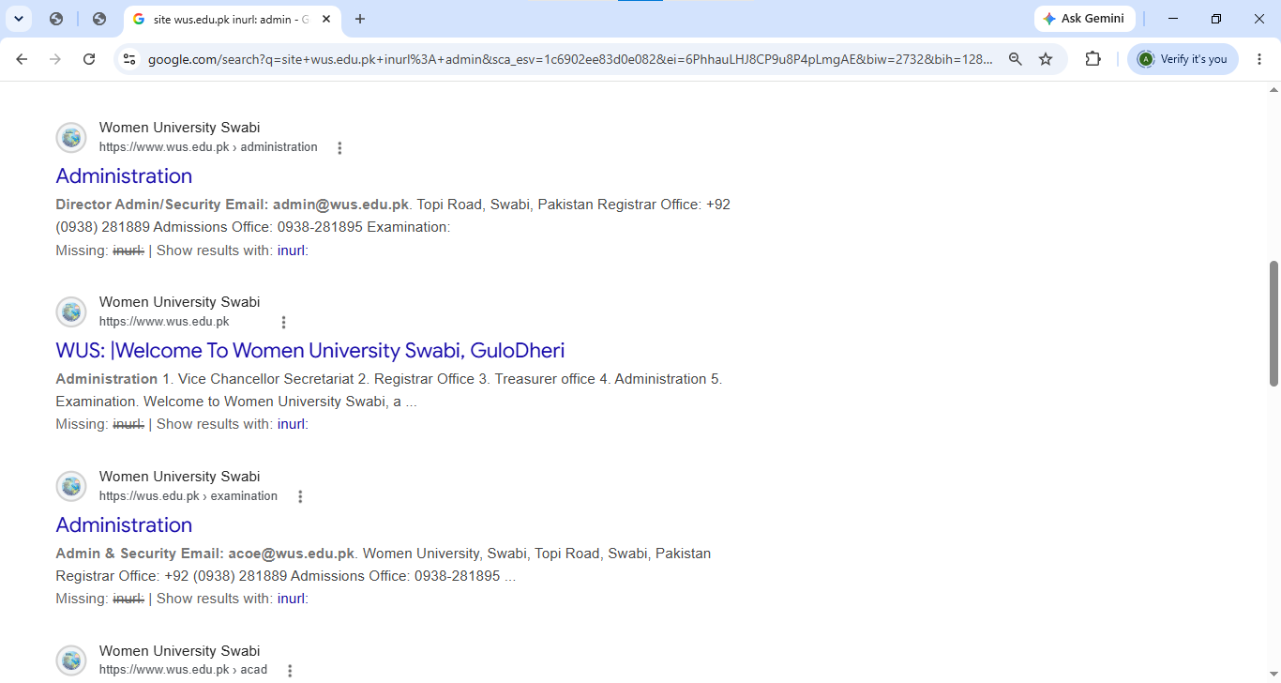
Tool 2 – WHOIS:
To obtain public domain registration information.
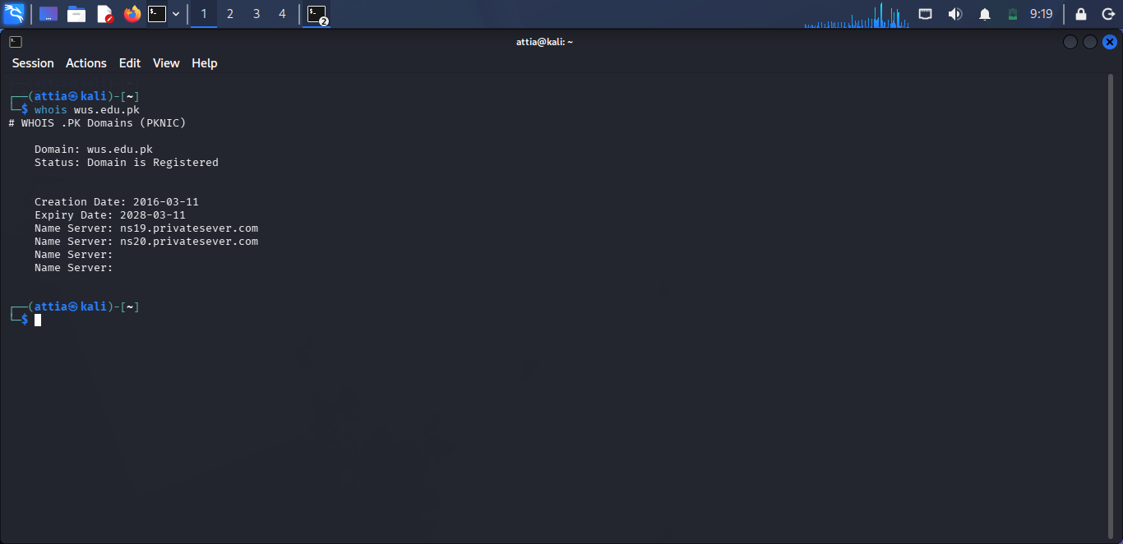
Domain is registered.
Registration information was displayed.
Name Servers:
ns19.privateserver.com
ns20.privateserver.com
Tool 3 – DNS Lookup:
To retrieve DNS records of the target domain.
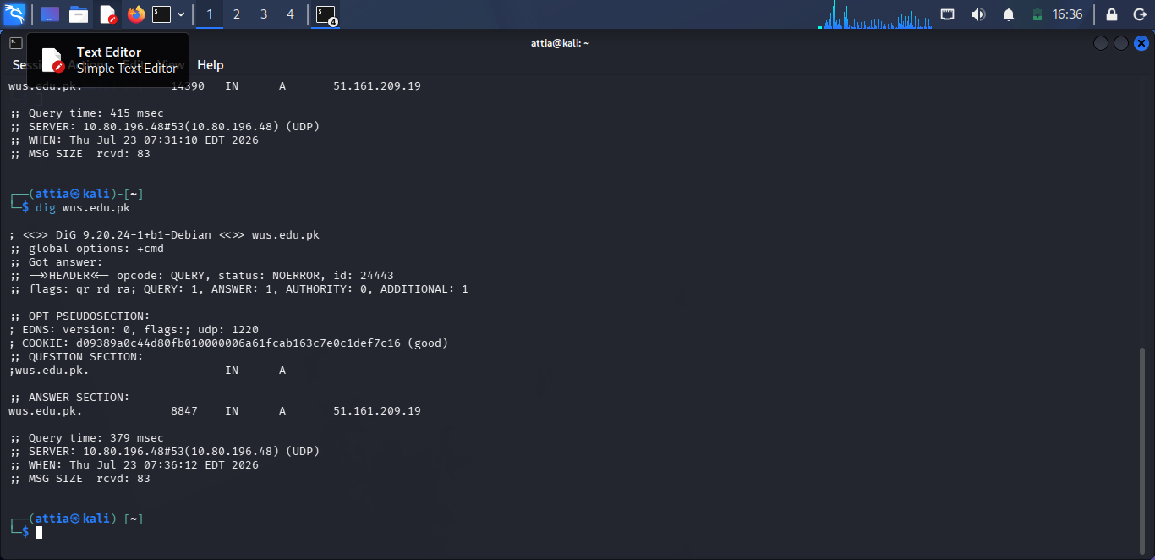
DNS information of the target domain was successfully retrieved.
Tool 4 – Name Server Lookup:
identify the authoritative name servers.
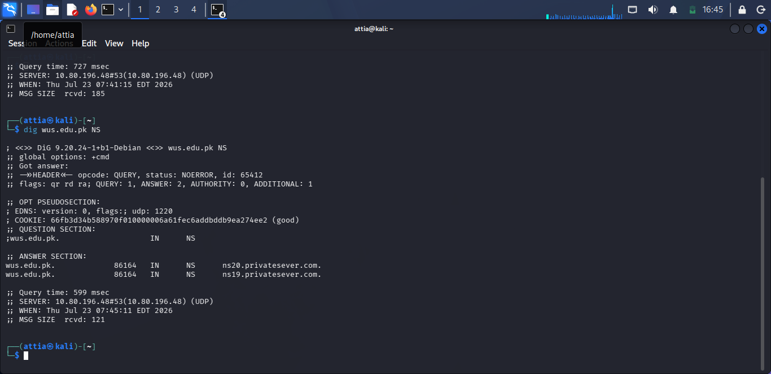
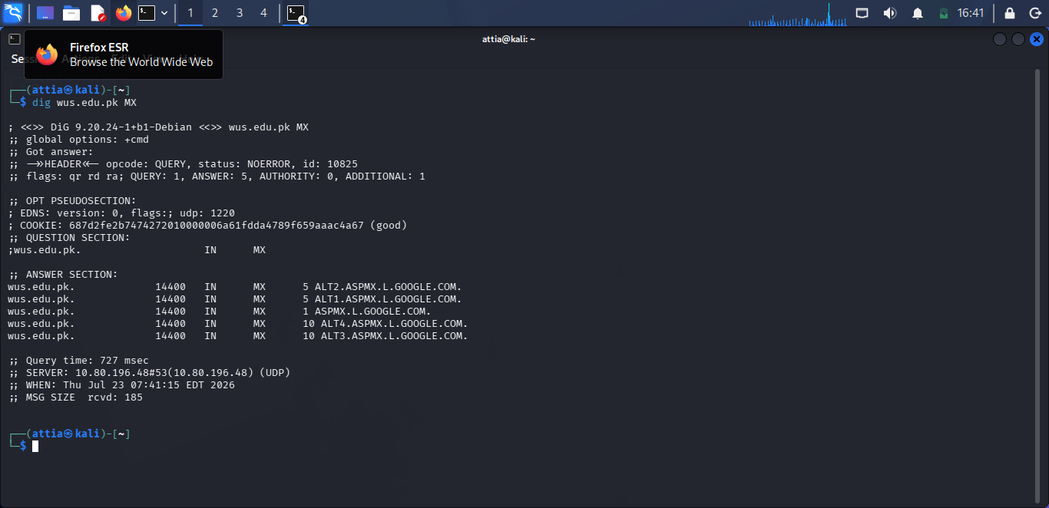
ns19.privateserver.com
ns20.privateserver.com
Tool 5 – Zone Transfer Test:
To check whether DNS Zone Transfer is allowed.
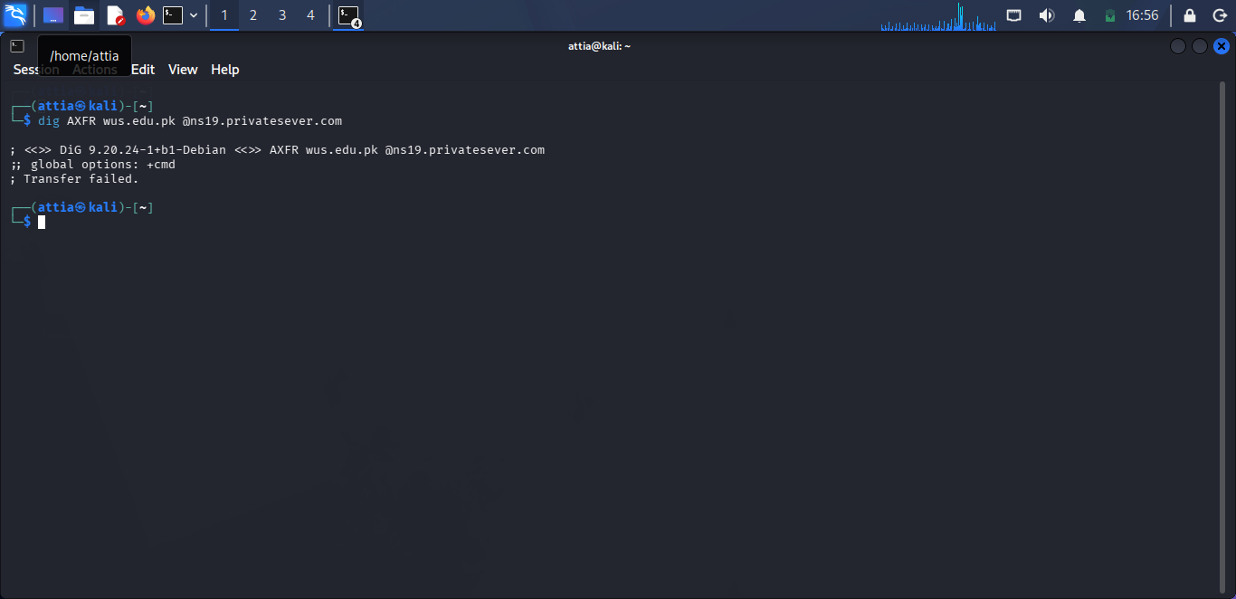

Connection timed out / Zone Transfer was not allowed.
Observation:
The DNS server is securely configured and does not allow public zone transfers.
Tool 6 – theHarvester:
To collect publicly available email addresses, IP addresses, and subdomains.

Email Found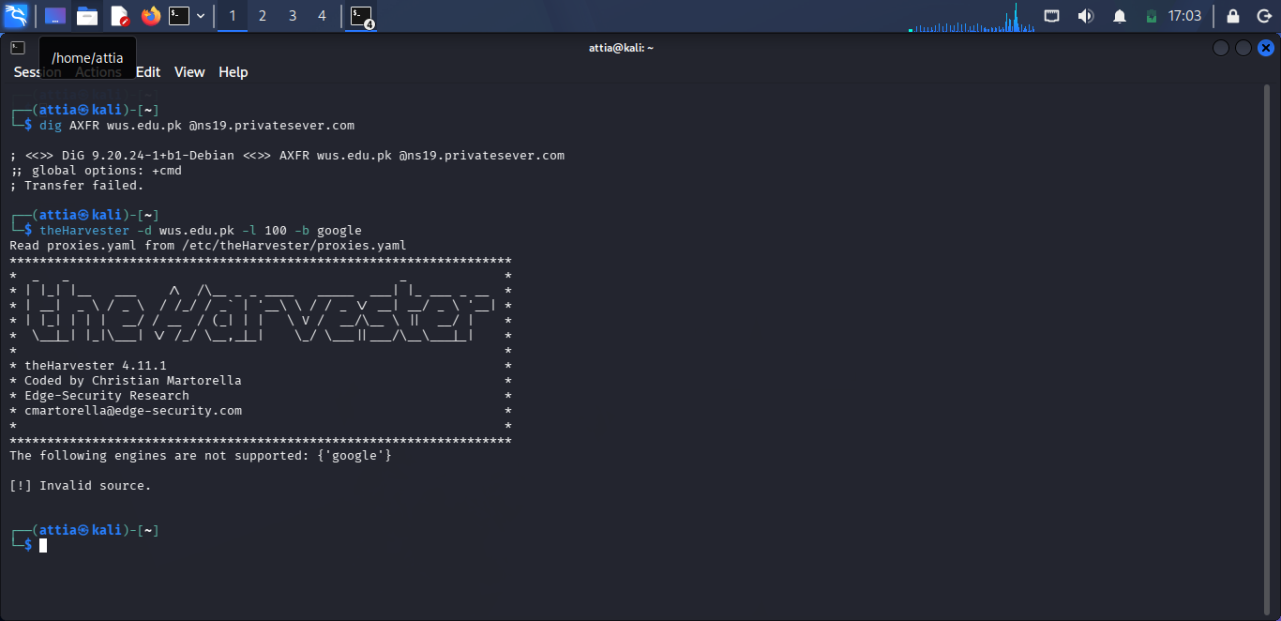

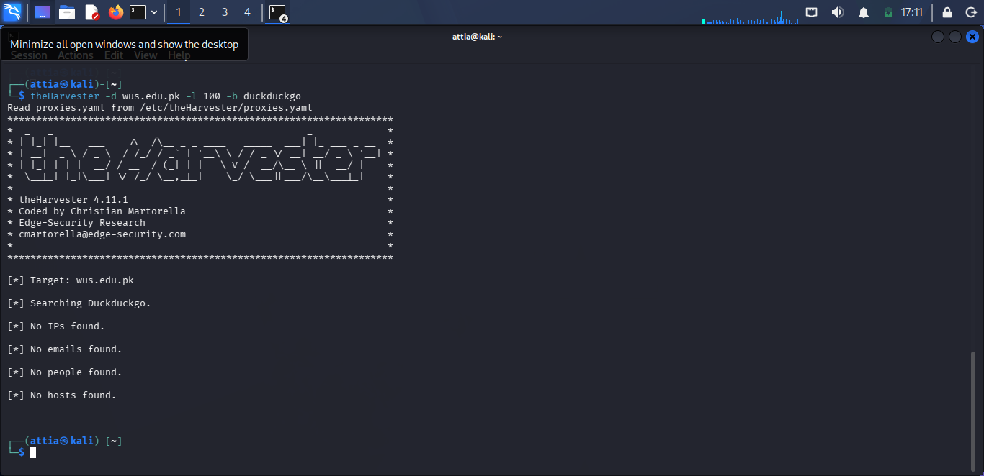
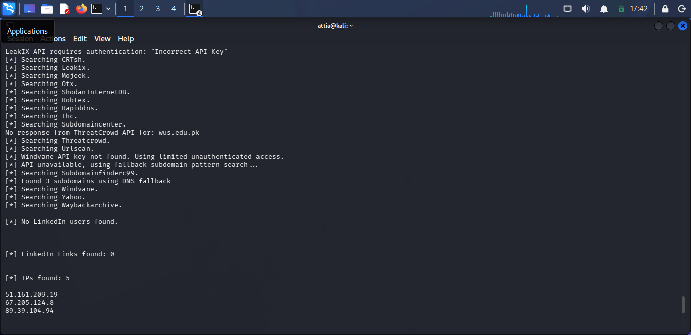
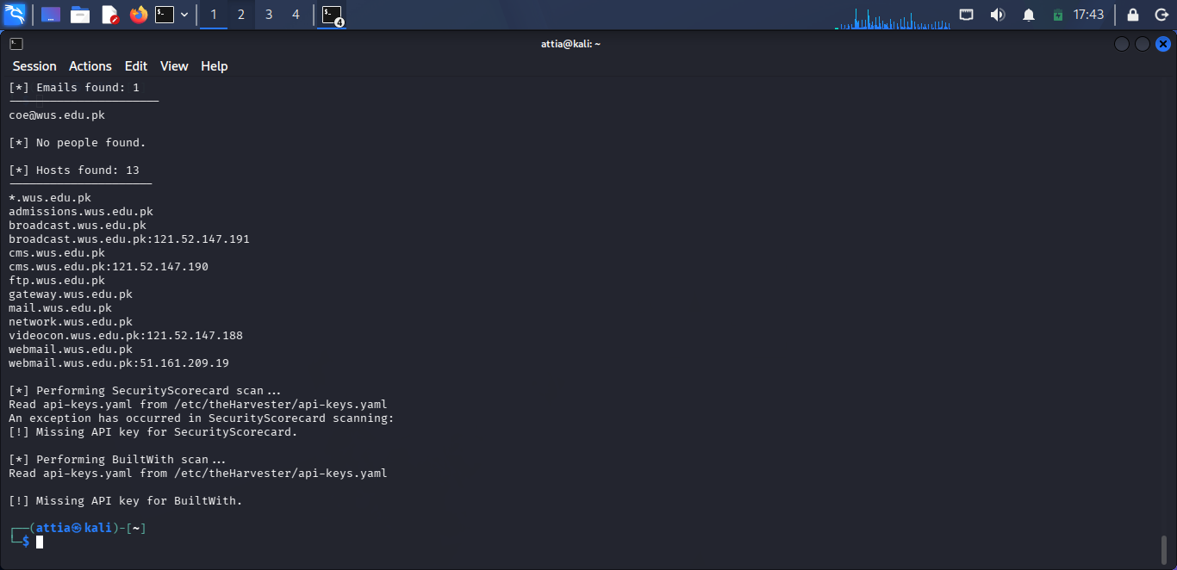

coe@wus.edu.pk
IP Addresses
51.161.209.19
67.205.124.8
89.39.104.94
Hosts/Subdomains
wus.edu.pk
admissions.wus.edu.pk
webmail.wus.edu.pk
Observation
theHarvester successfully discovered one public email address, three IP addresses, and three hosts/subdomains. Some sources required API keys, but public information was collected successfully.
Conclusion:
The reconnaissance of wus.edu.pk was successfully completed using OSINT techniques.
The following tools were used:
Google Dorks
WHOIS
DNS Lookup (dig)
Name Server Lookup
Zone Transfer Test
theHarvester
The project successfully collected publicly available information, including indexed pages, PDF files, domain registration details, DNS records, name servers, email addresses, IP addresses, and subdomains. No unauthorized access or exploitation was performed.

